

Lab Manual
Programming of AI

Submitted to:
Sir Samraiz

Submitted by:
M Javed Mehmood

Reg No.:
2023-BS-AI-029

DEPARTMENT OF COMPUTER SCIENCE
Table Of Content

Lab 1: Programming Fudamentals…………….. 3
Lab 2: OOP
Lab 3: NumPy
Lab 4: Seaborn,Metplotlib,SKlearn

Lab 1: Programming Fudamentals

Program 1:
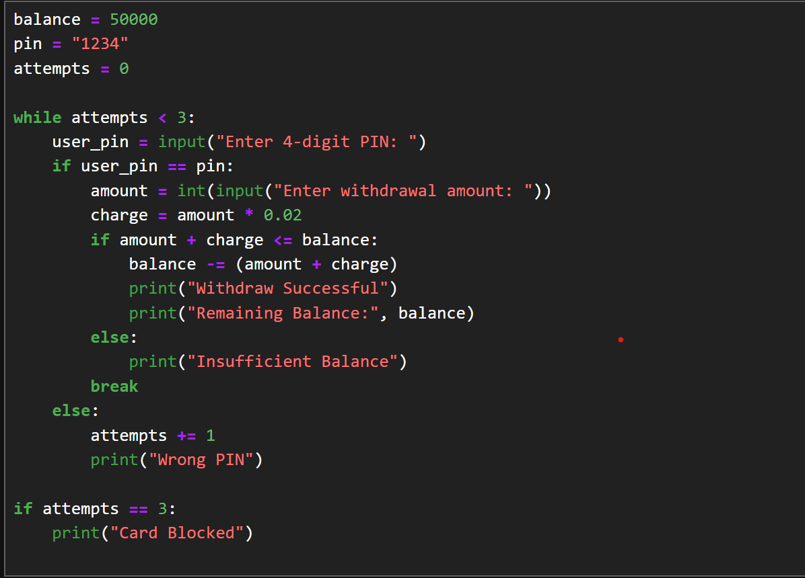
Output:
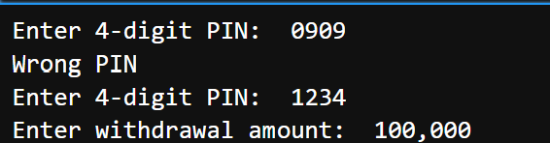

Program 2:

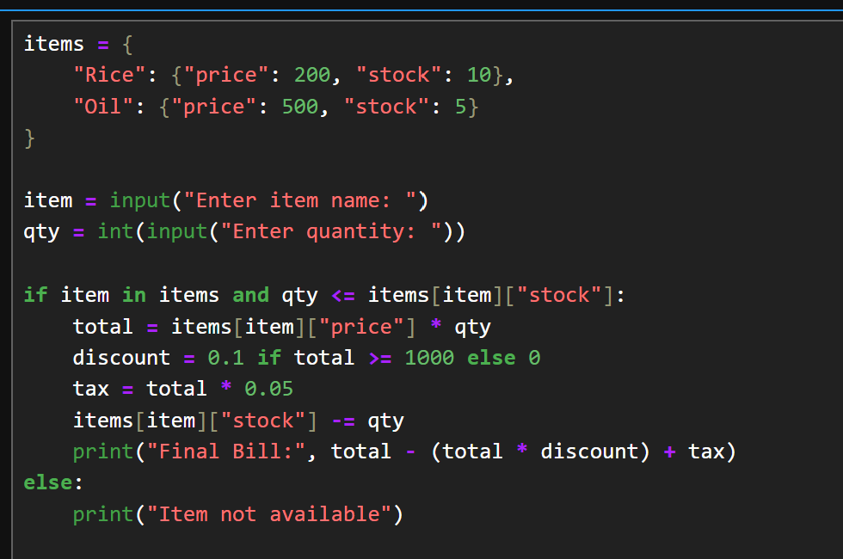

Output:
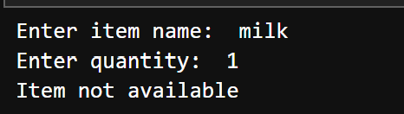

Program 3:

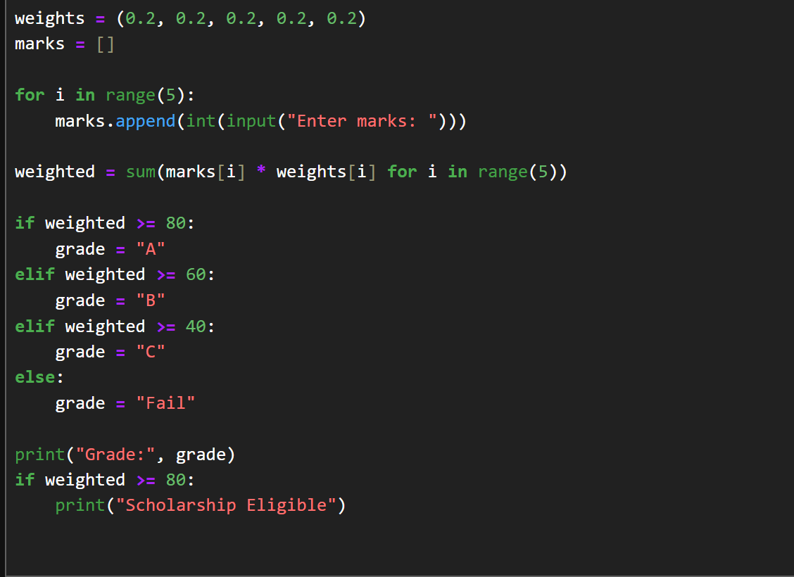
Output:
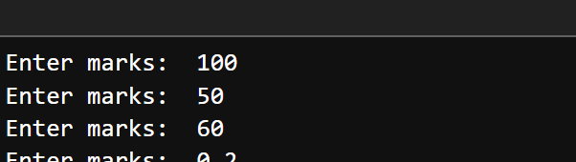

Program 4:
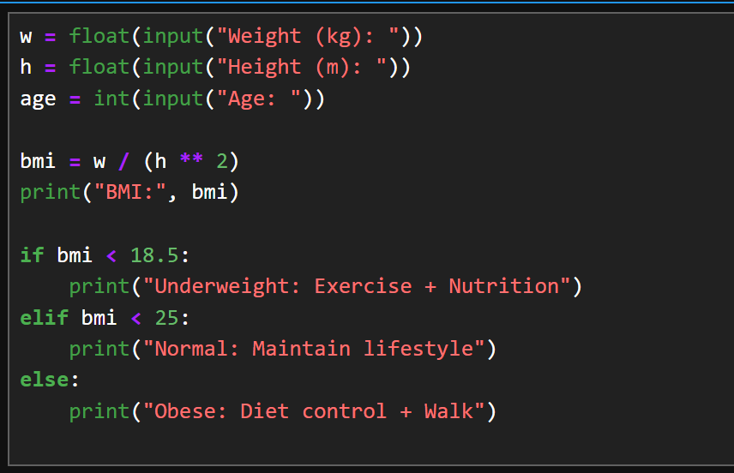
Output:
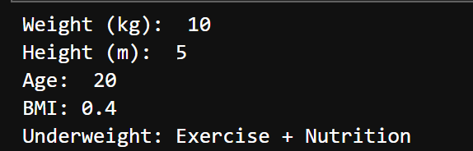

Program 5:
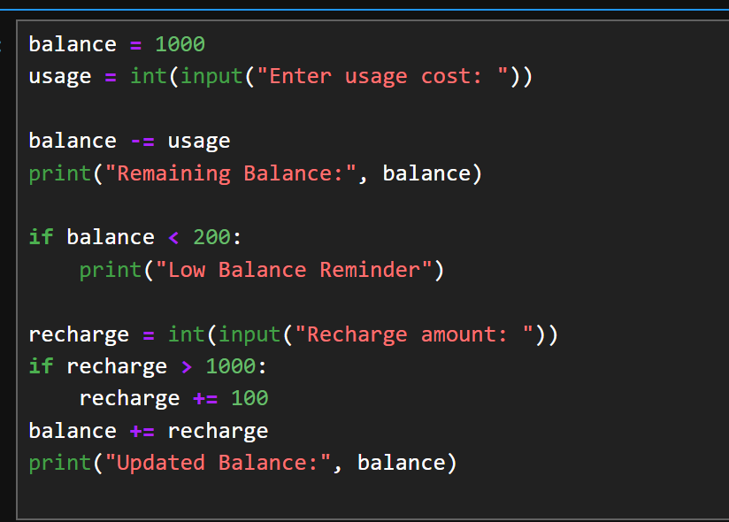
Output:
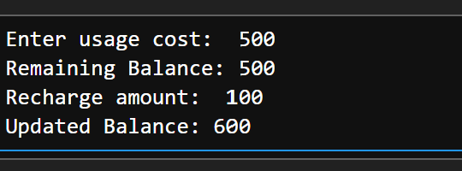

Program 6:
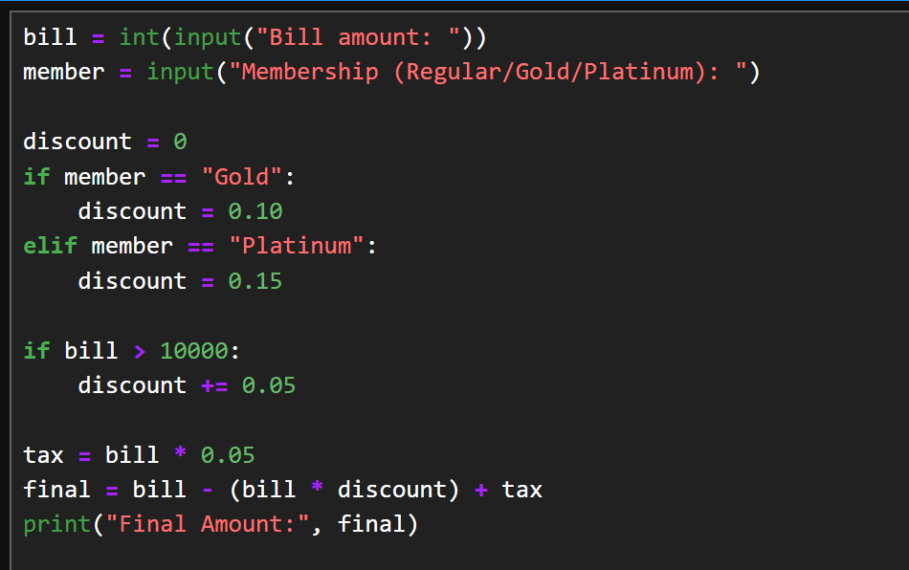

Output:
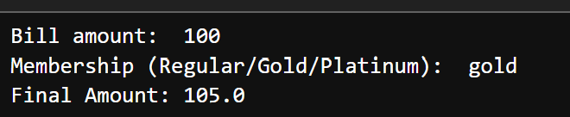

Program 7:
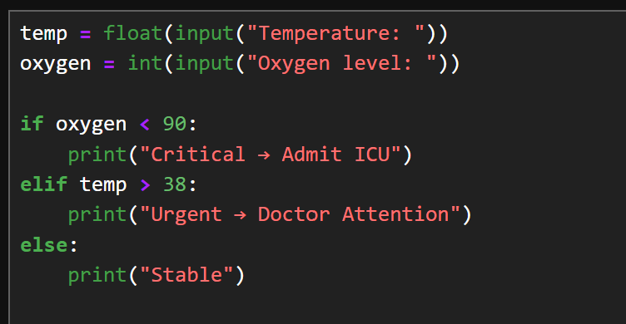
Output:
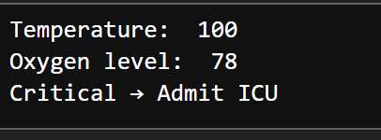

rogram 9:
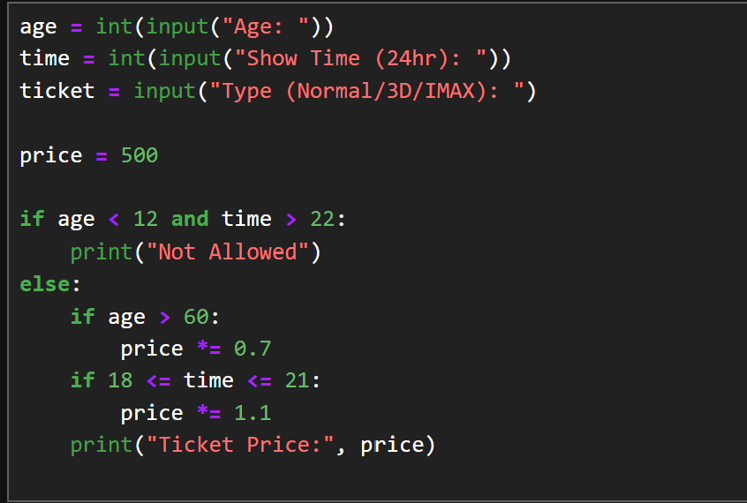
Output:
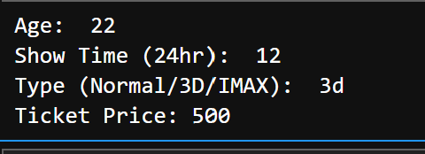

Program 10:
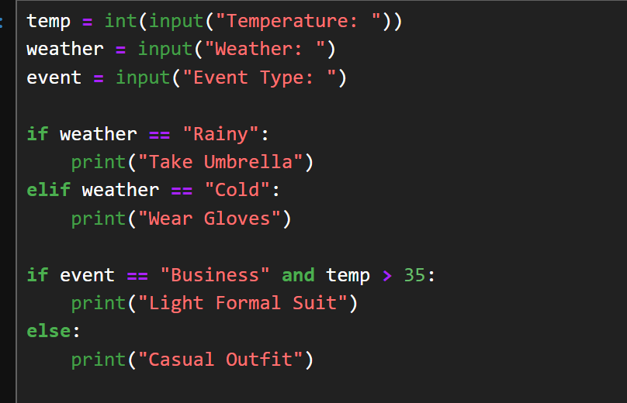
Output:
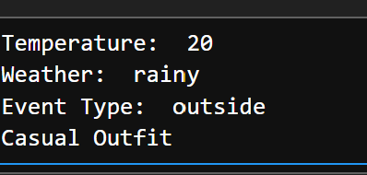

Q11. ATM Withdrawal with Note Counting + Receipt.
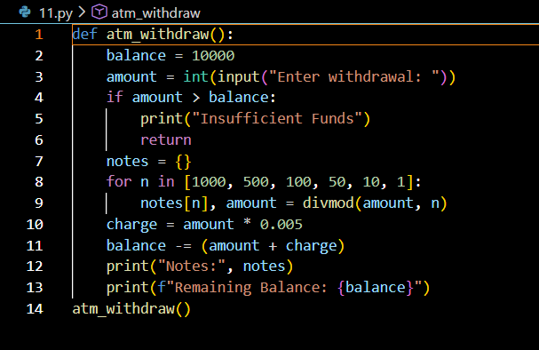
Output
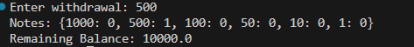

Q12. Library Fine Calculator with Membership Levels
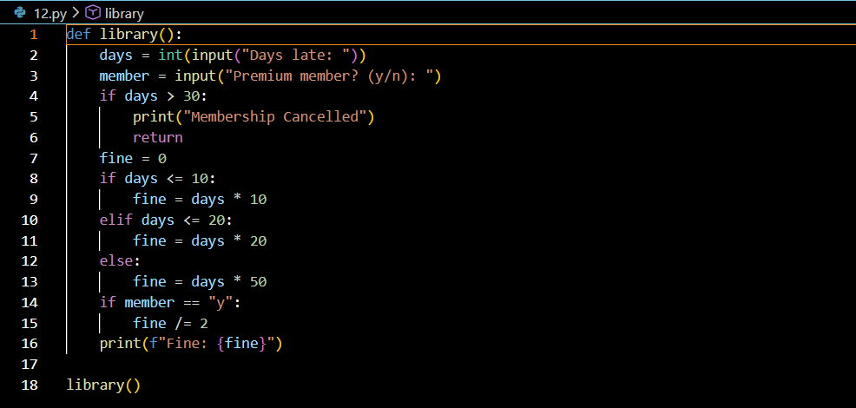
Output
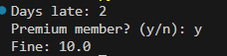

Q13. Sales Analysis Dashboard
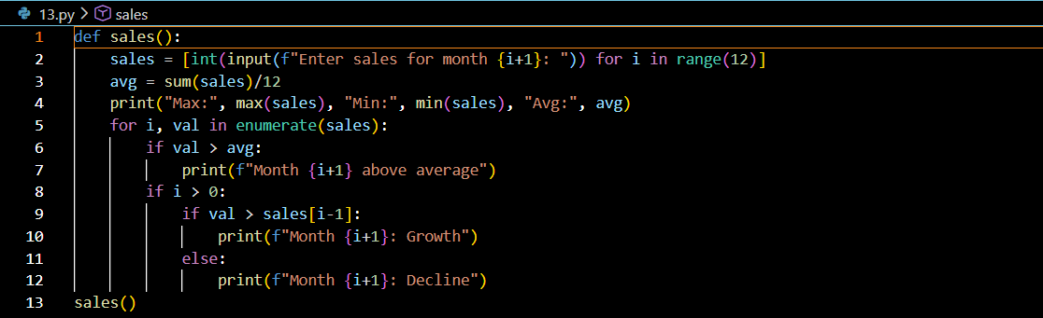

Output
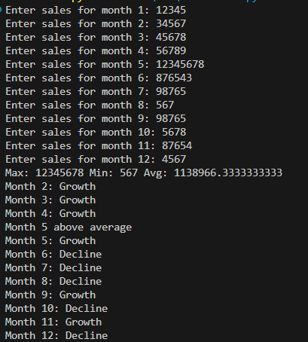
Q14. Multiplication Puzzle with Random Blanks
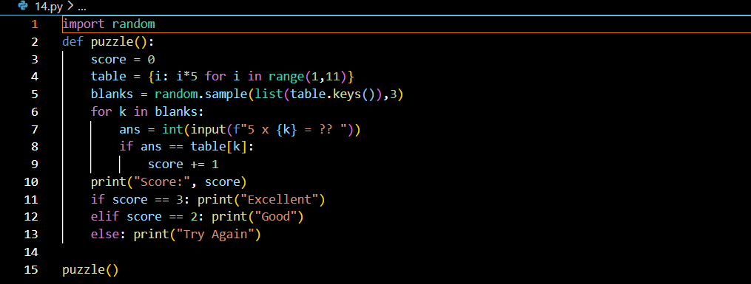

Output
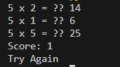

Q15. Password Strength + Re-entry Attempts
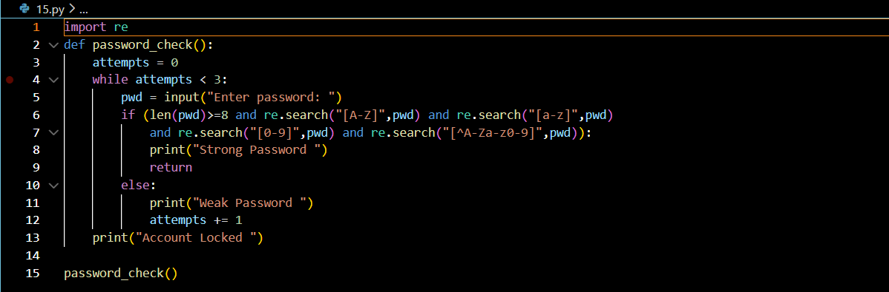
Output
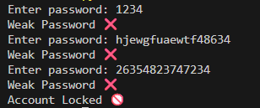

Q16. Electricity Bill with Slabs & Penalty
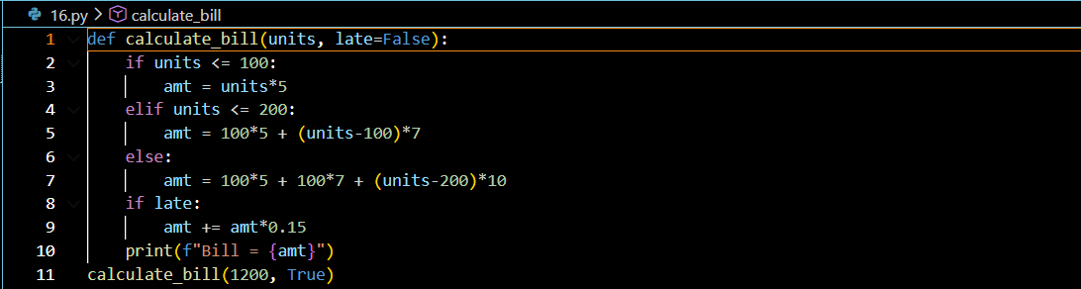

Output
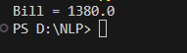

Q17. Cricket Match Predictor with Multiple Conditions
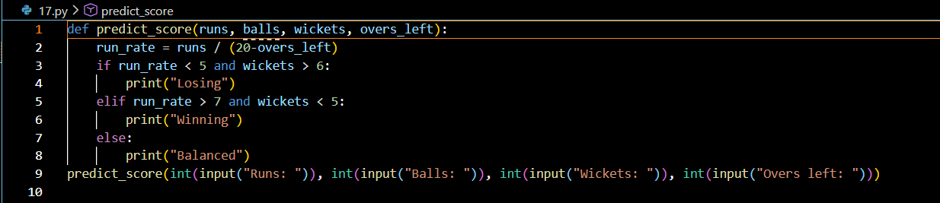
Output
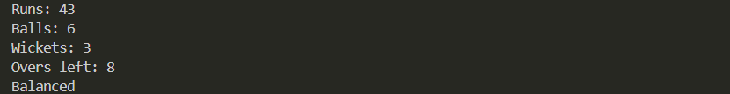

Q18. Hotel Booking with Tax & Discount

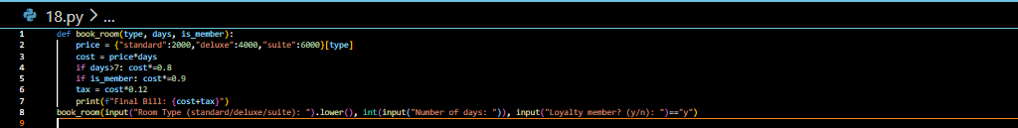
Output
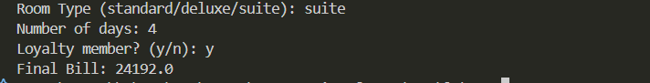

Q19. Flight Fare Calculator with International Tax

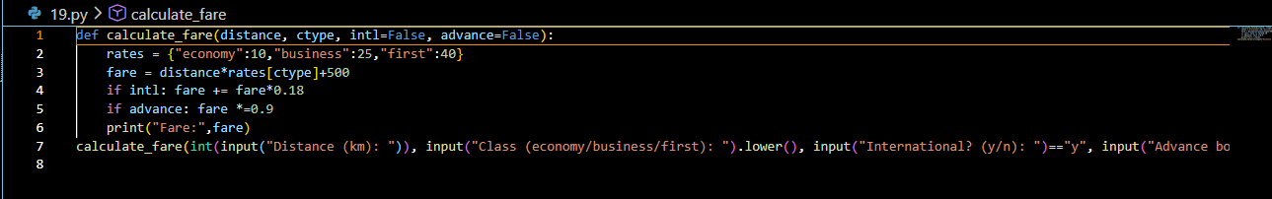
Output
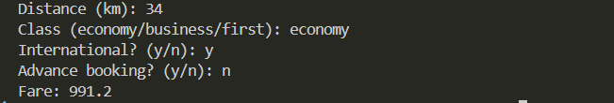

Q20. Smart Vending Machine with Wallet System

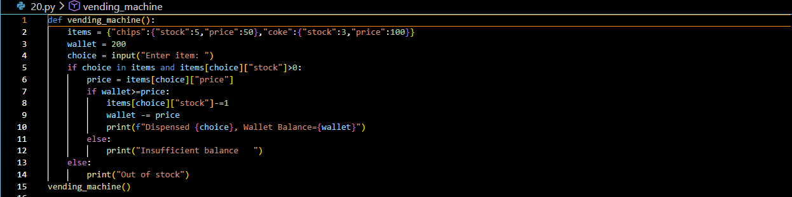
Output

LAB 2 -OOP
Program 1:

Create a `BankAccount` class that represents a bank account. It should have attributes for account number, account holder name, and balance. Include methods to deposit, withdraw, and display balance. Ensure withdrawals cannot exceed the available balance.

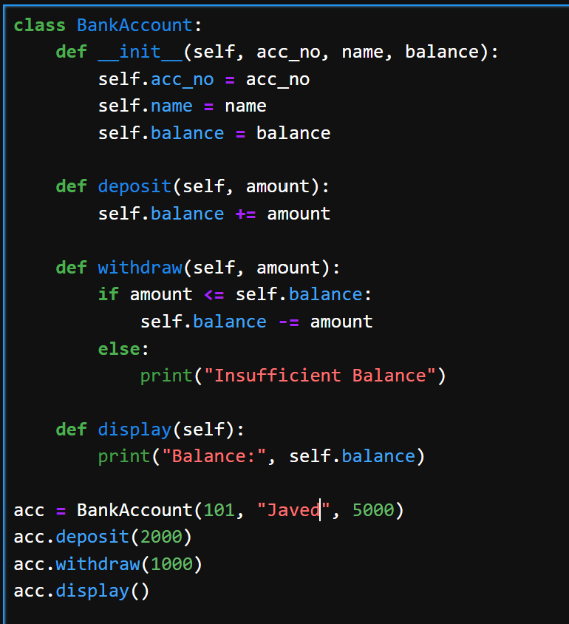

Output:
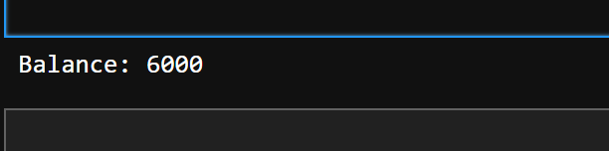

Progrm 2:

Design a `Book` class with attributes like title, author, ISBN, and availability status. Create a `Library` class that can add books, search for books by title/author, check out books, and return books. Track which books are currently available.

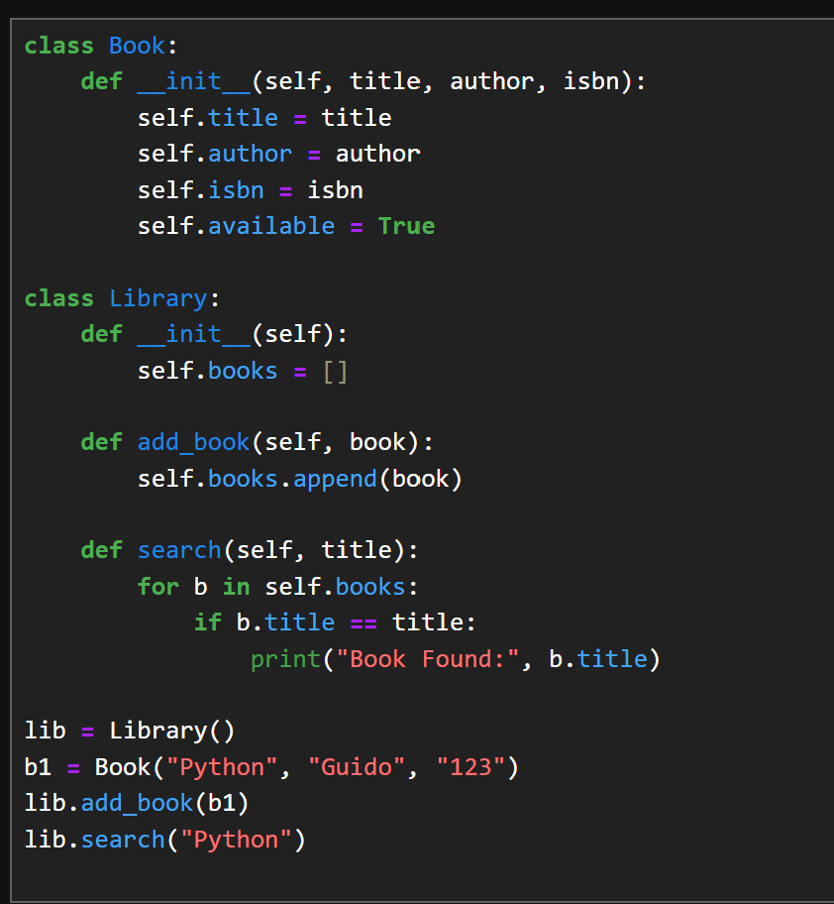
Output:
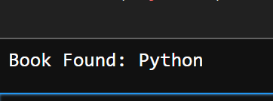

Progrm 3:

Create a `Student` class with attributes for student ID, name, and a list of grades. Implement methods to add grades, calculate average grade, and determine the letter grade (A, B, C, etc.). Add a method to display student information with their performance summary.

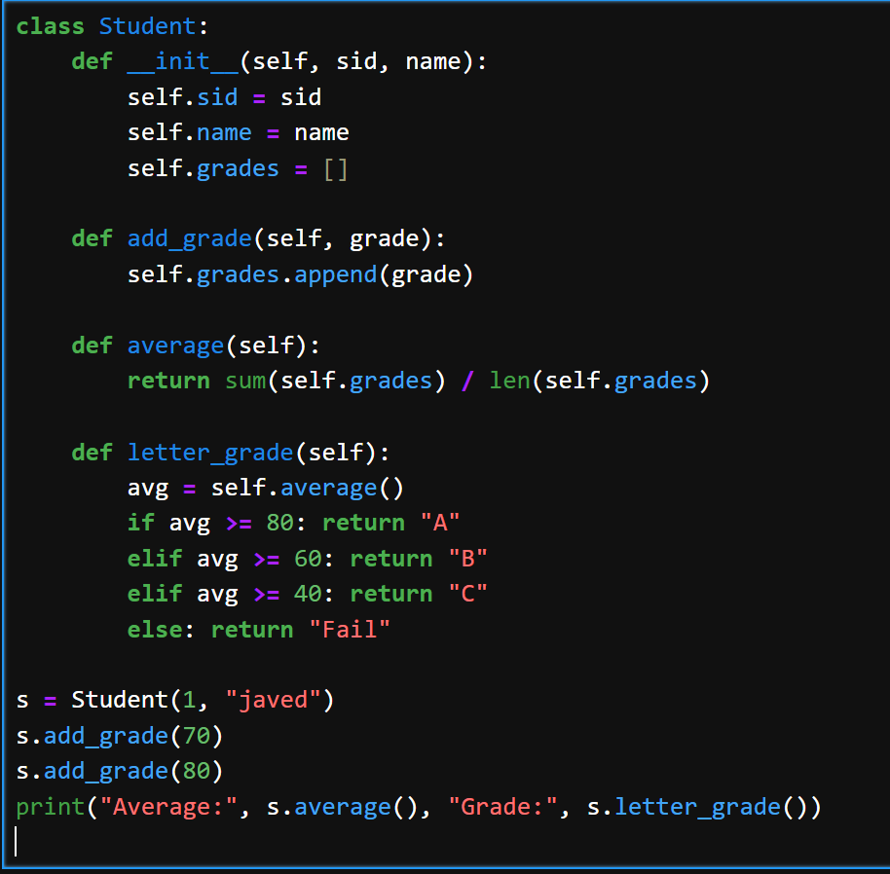

Output:
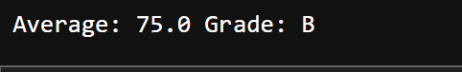

Program 4:

Design a `MenuItem` class for food items (name, price, category) and an `Order` class that can add multiple items, calculate total cost, apply discounts, and generate receipts. Include tax calculation functionality.

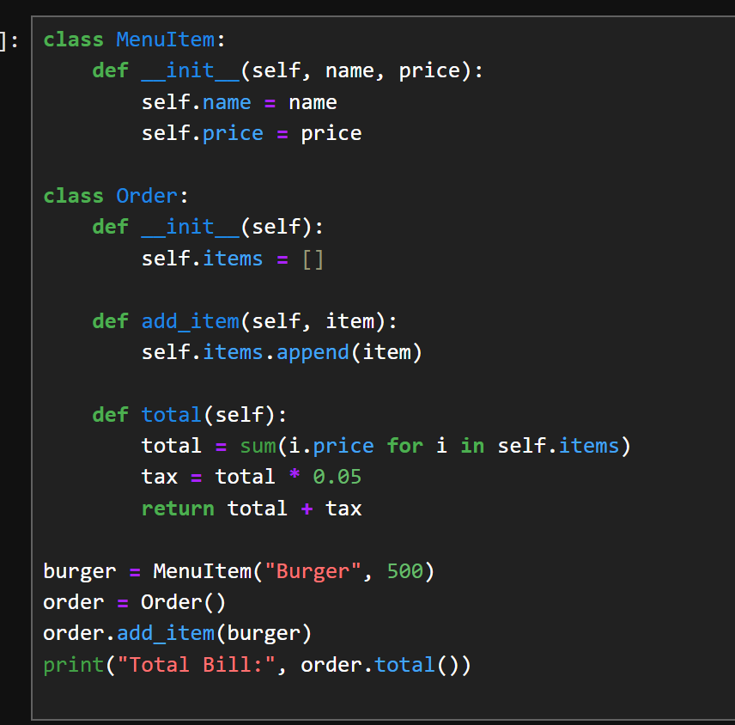

Output:
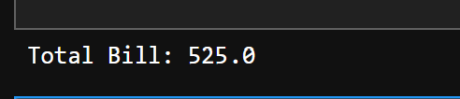

Program 6:

Design an `Employee` class with attributes for employee ID, name, position, and salary. Create methods to calculate monthly salary, annual salary, and apply raises. Include functionality to track employee details and employment duration.

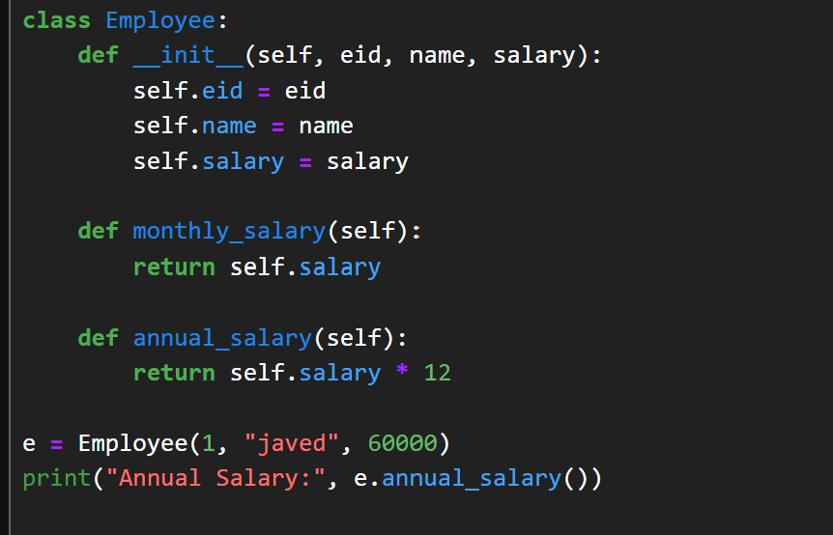

Output:
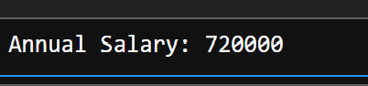

Program 7:

Create a `Product` class with attributes for product ID, name, price, and stock quantity. Design a `ShoppingCart` class that can add products, remove products, calculate total cost, and handle checkout process while updating inventory.

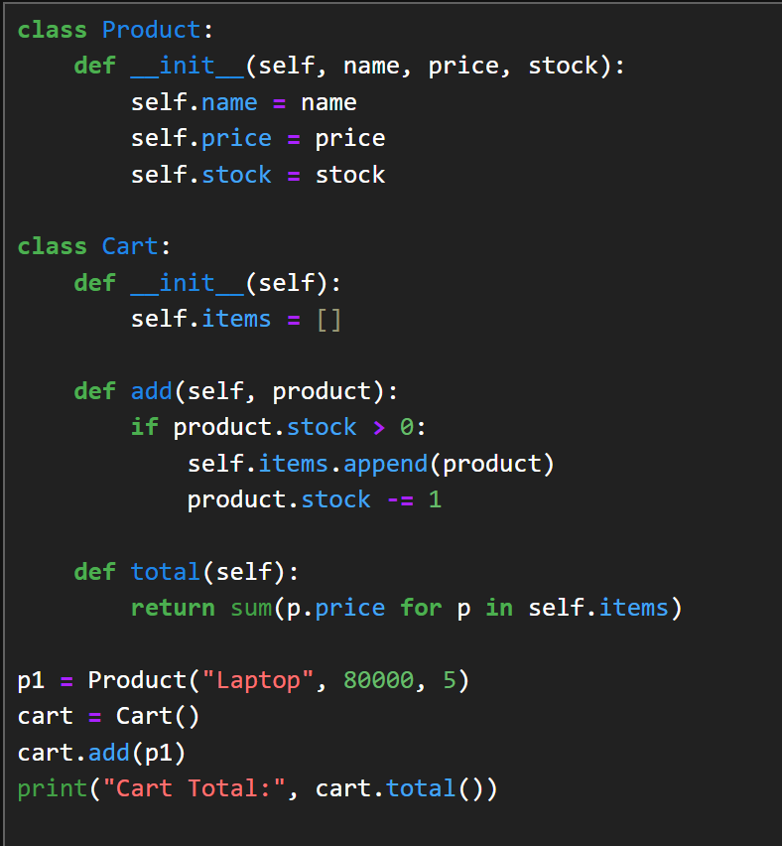

Output:
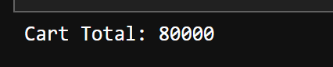

Program 8

Design a `Patient` class to store patient information (ID, name, age, medical history) and an `Appointment` class to manage doctor appointments. Include functionality to schedule, cancel, and view appointments.

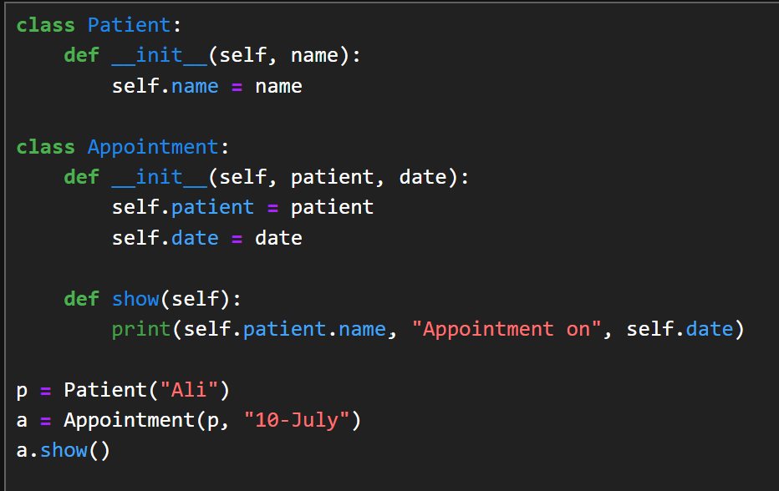

Output:
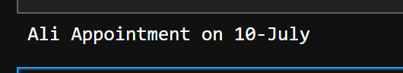

Program 9;

Create a `User` class for a social media platform with attributes for username, email, friends list, and posts. Implement methods to add friends, create posts, and display user timeline. Include privacy settings for posts.

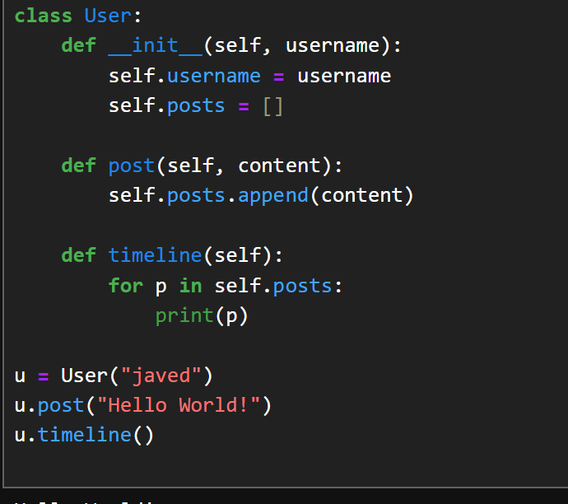

Output:
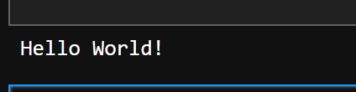

Program 10:
Design a `Room` class with room number, type (single/double/suite), price, and availability. Create a `Booking` class to handle room reservations, check-in/check-out dates, and calculate total stay cost.

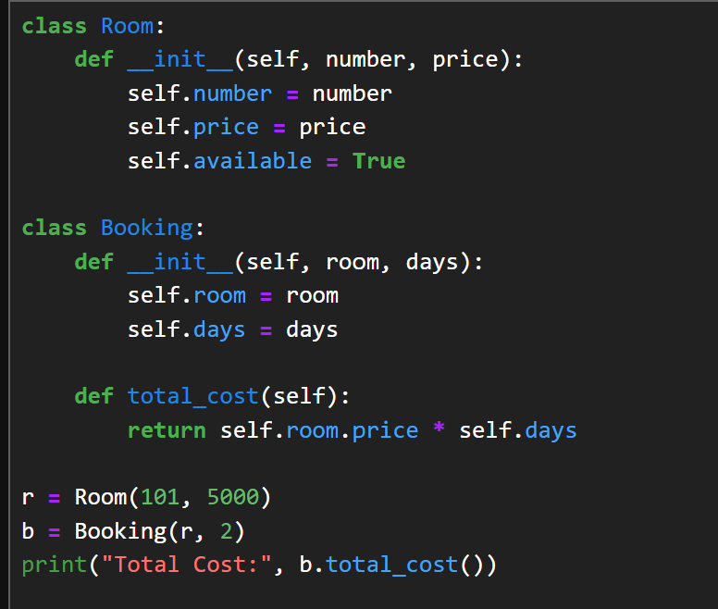

Output:
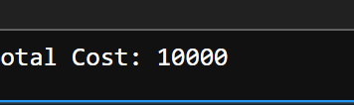

LAB 3-NUMPY

Question 1: A weather station records temperatures (°C) for 7 days
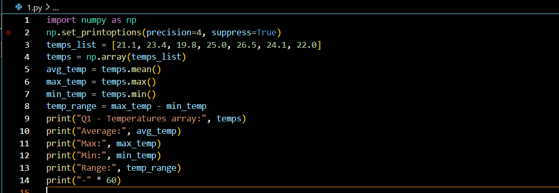
Output
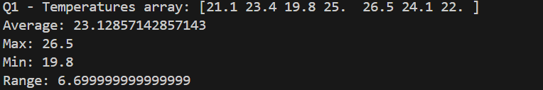

Question 2: A fruit store records daily sales of apples for 4 weeks

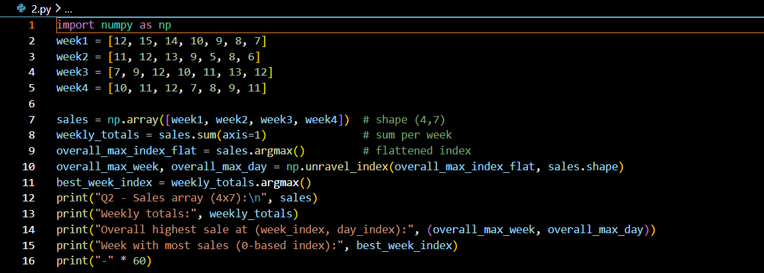

Output
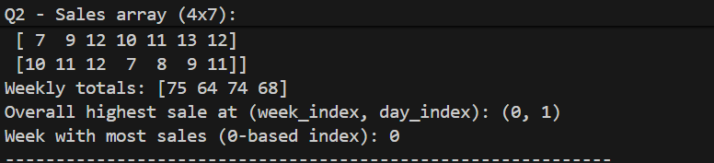

Question 3: Students received marks in a test

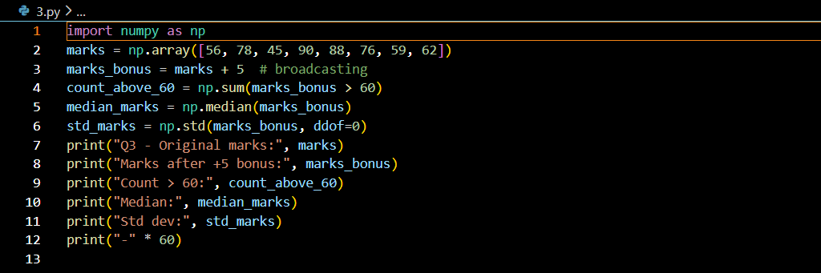
Output
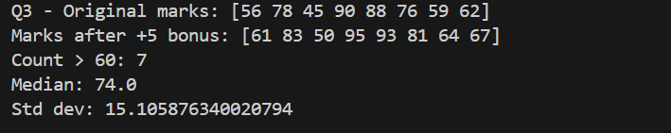

Question 4: A smartwatch stores daily step-counts for a user for 30 days.

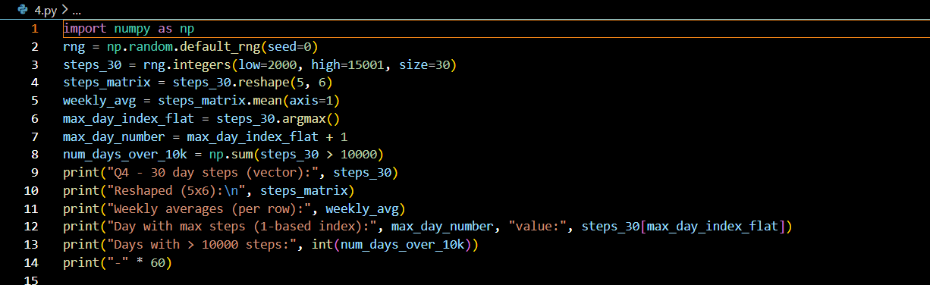
Output
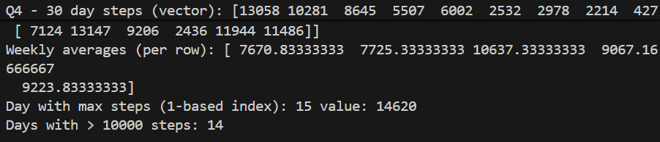

Question 5: Heart rate readings (in BPM) for 10 patients recorded 4 times per day
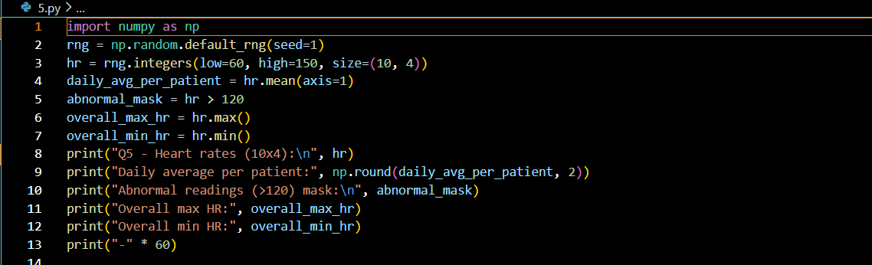
Output
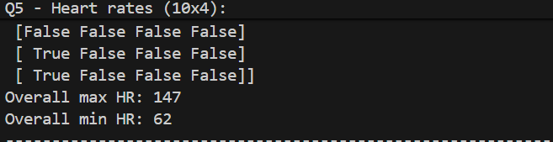

Question 6: Two branches of a store record monthly sales (in thousands)

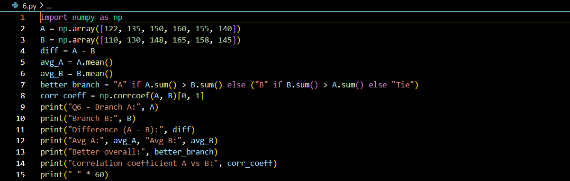
Output
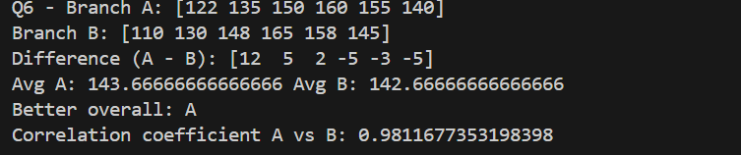

Question 7: Given a 4×4 grayscale image

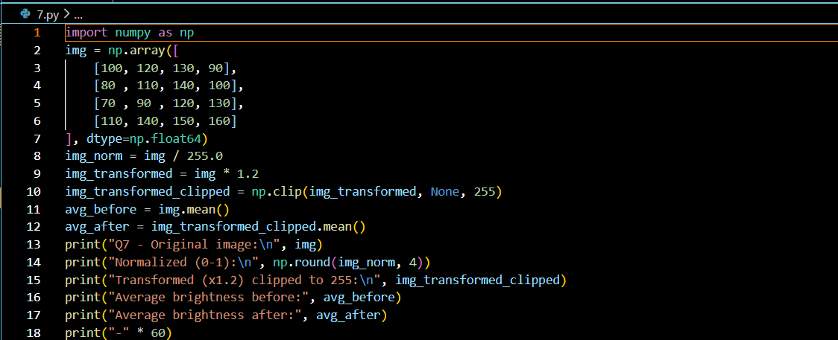
Output
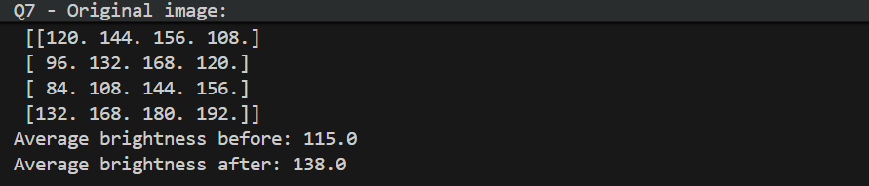

Question 8: Dataset contains 100 samples with 4 features each.

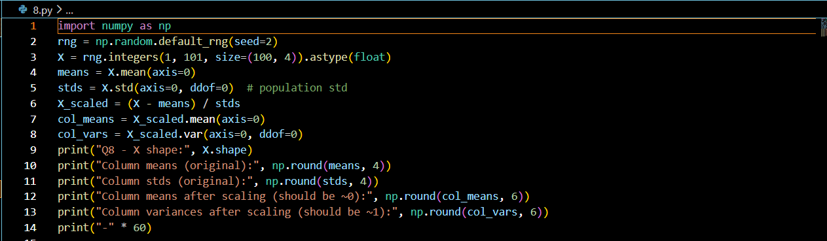
Output
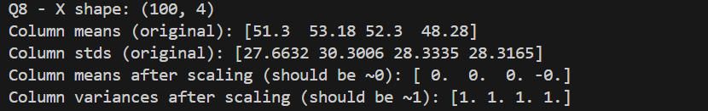

Question 9: Simulate traffic density (cars per minute) recorded by 6 sensors over 24 hours.
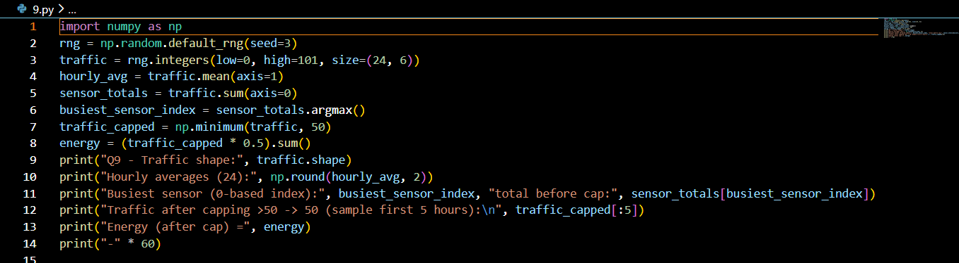
Output
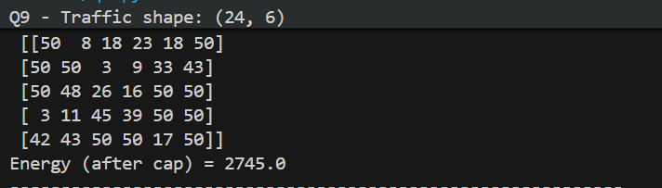

Question 10: You are simulating forces in a mechanical system.

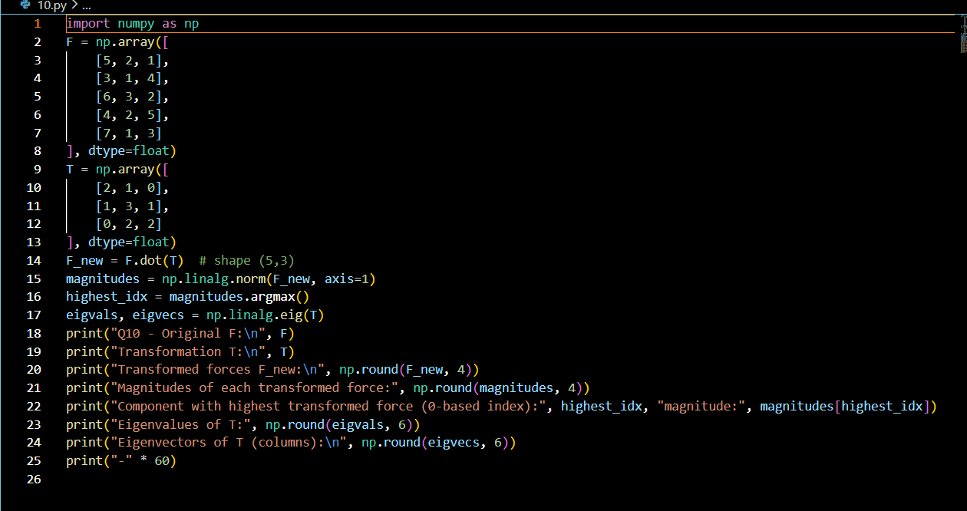
Output
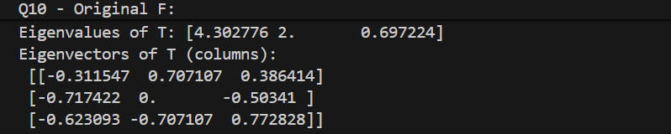

Lab 4:Seaborn,Matplotlib,SKlearn

Program 1:
Patient Stay Analysis (Healthcare)
You are given a dataset containing age, disease_type, and hospital_stay_days.
Write a Python program using Seaborn to:
- Plot the distribution of hospital stay days
- Compare hospital stay across different disease types
Identify which disease has the highest median stay

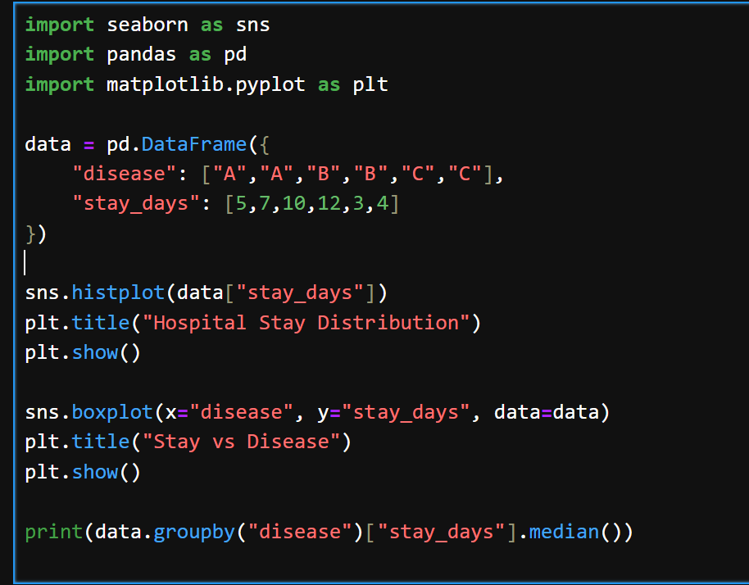

Output:
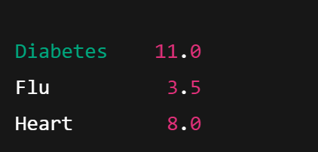

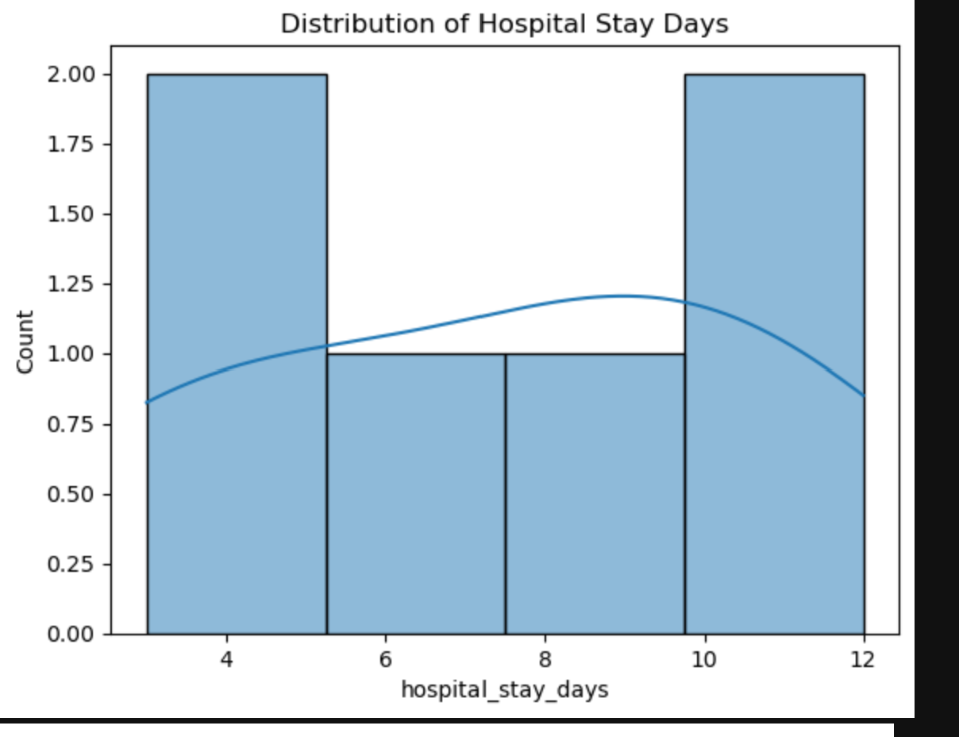
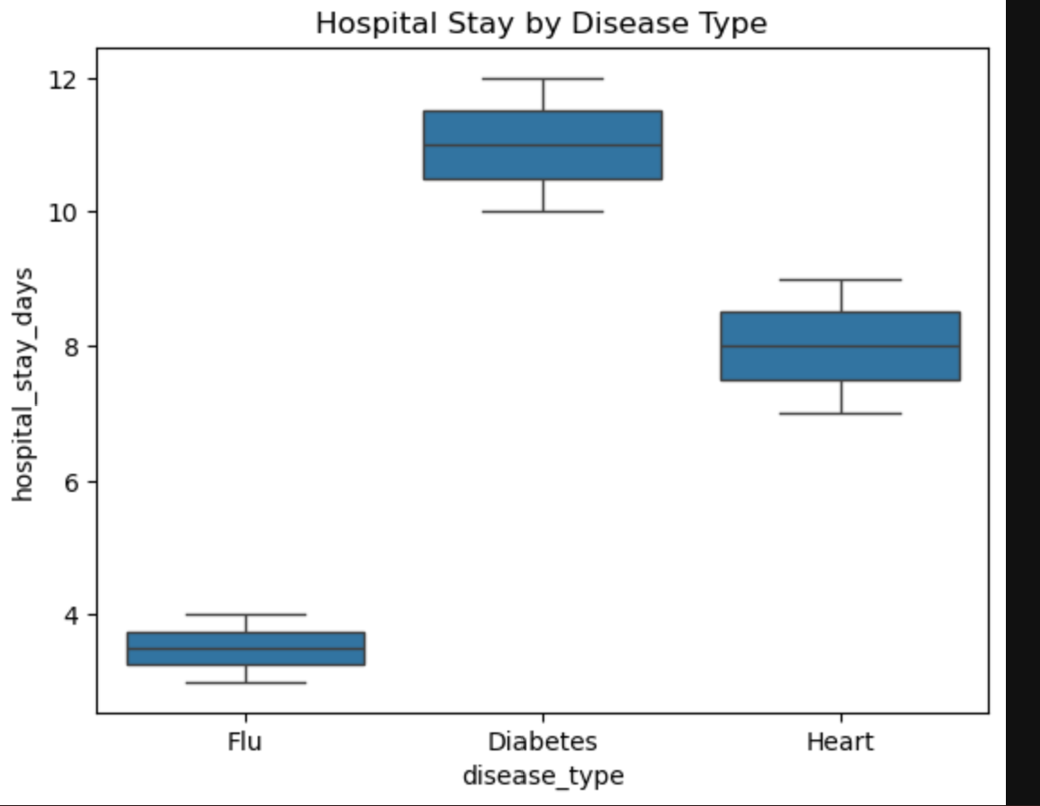

Program 2:
Sales Distribution Comparison (Business)
A retail dataset contains region and monthly_sales.
Write code to:
- Visualize sales distribution per region using Seaborn
- Detect regions with high sales variability
- Label the axes and add a title
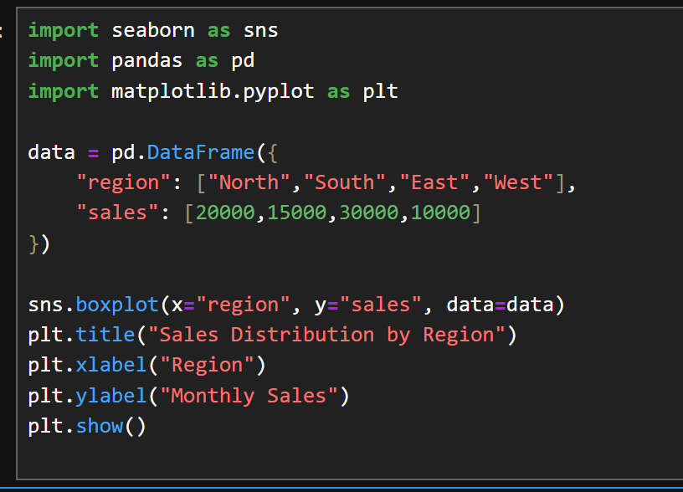
Output:
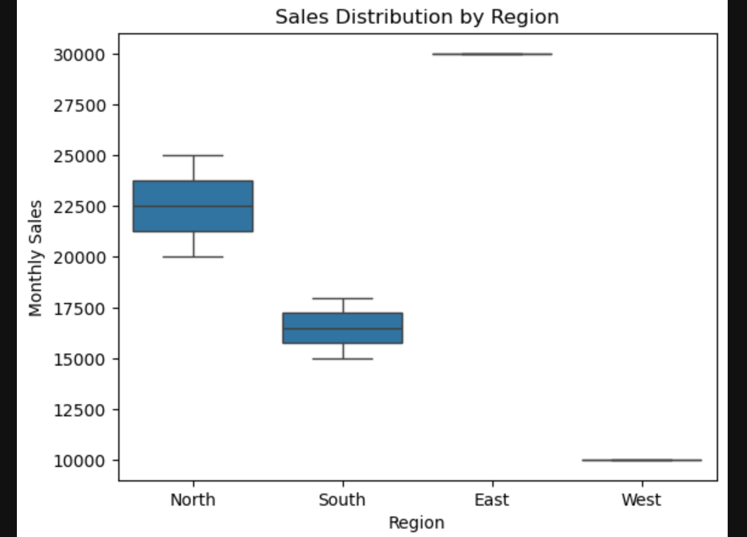

Program 3:
Student Performance Correlation (Education)
A dataset contains study_hours, attendance, and final_score .
Using Seaborn:
- Create a pair plot
- Plot a correlation heatmap
- Interpret which feature most affects the final score

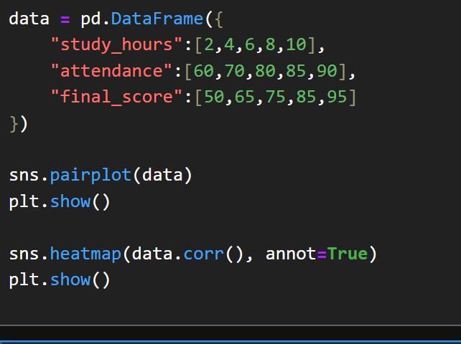

Output:
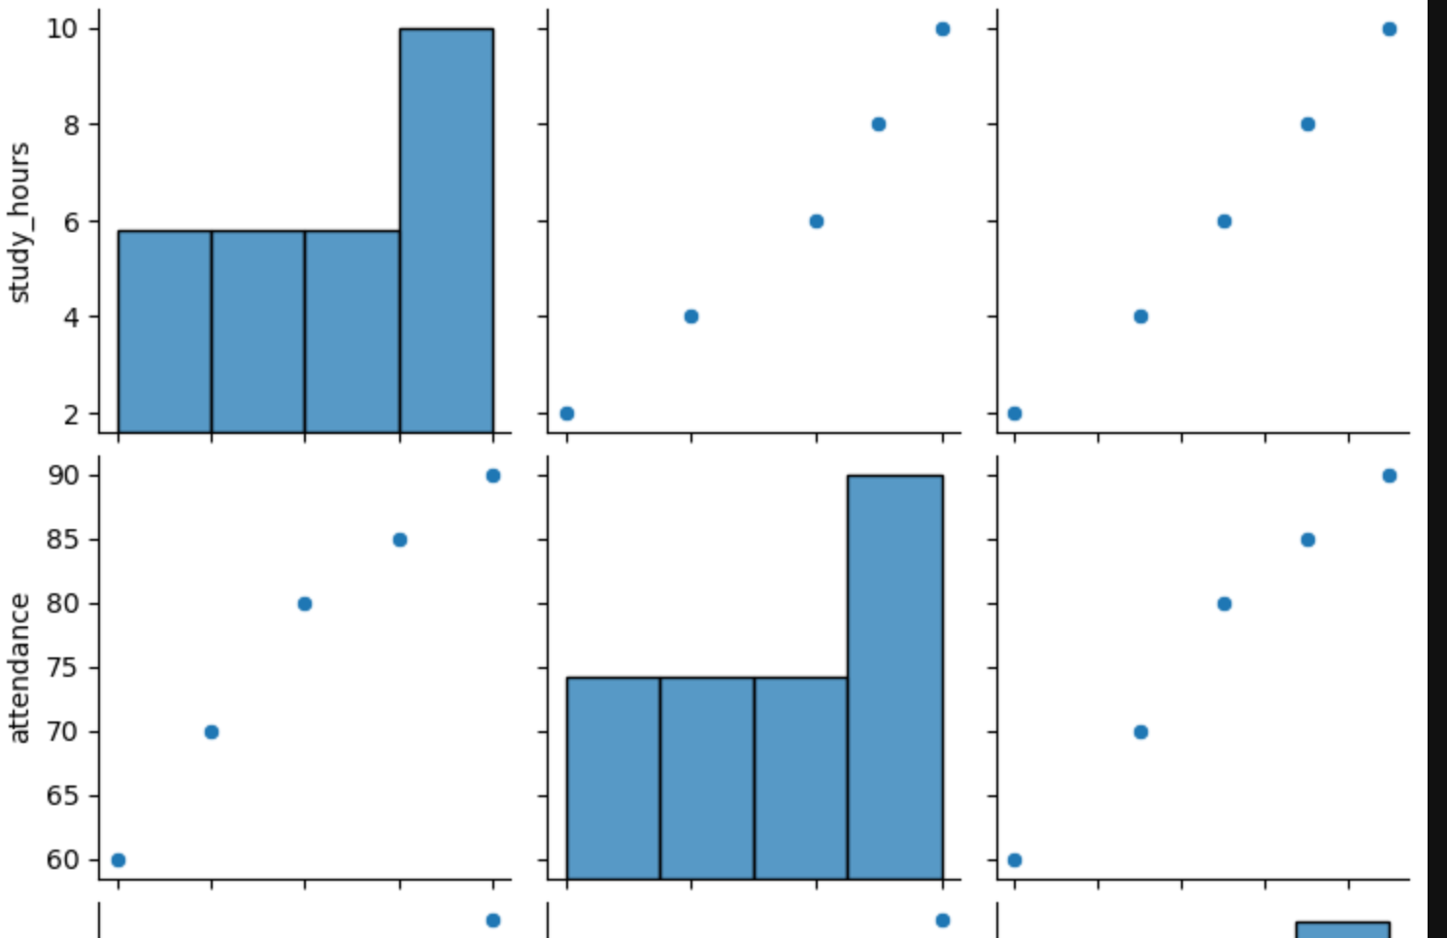

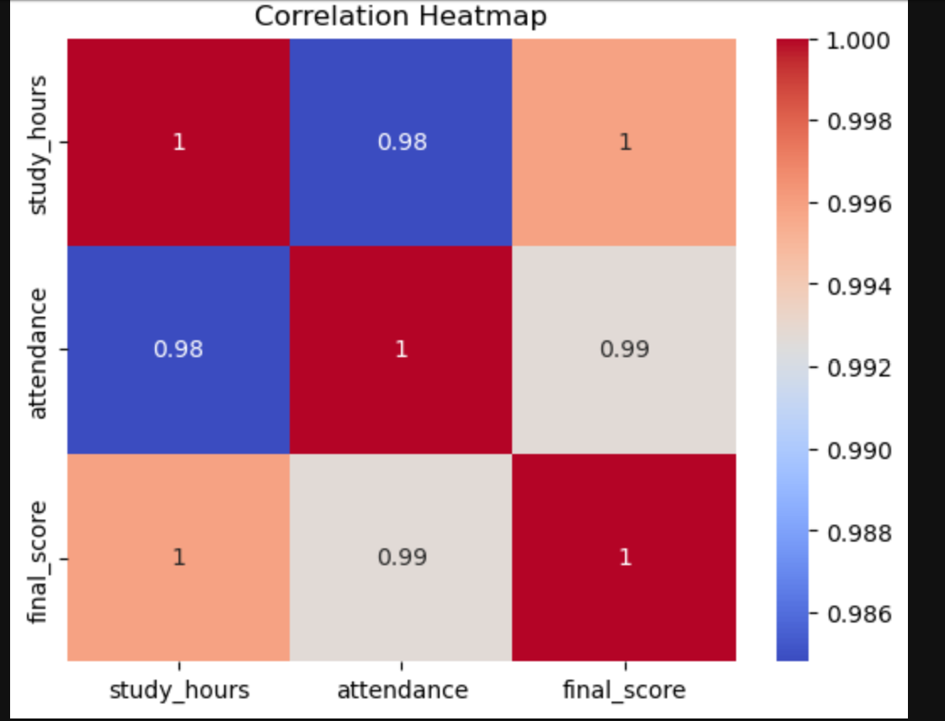

Program 4:
Customer Segmentation Visualization
Customer data includes age, annual_income, and spending_score.
Write a program to:
- Visualize relationships using Seaborn scatter plots
- Color-code points based on spending score
- Identify potential customer segments visually

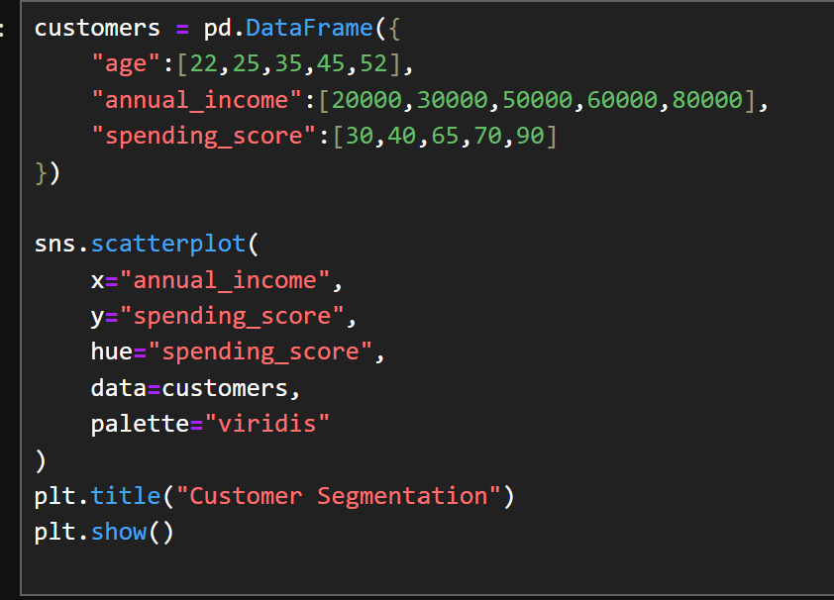

Output:
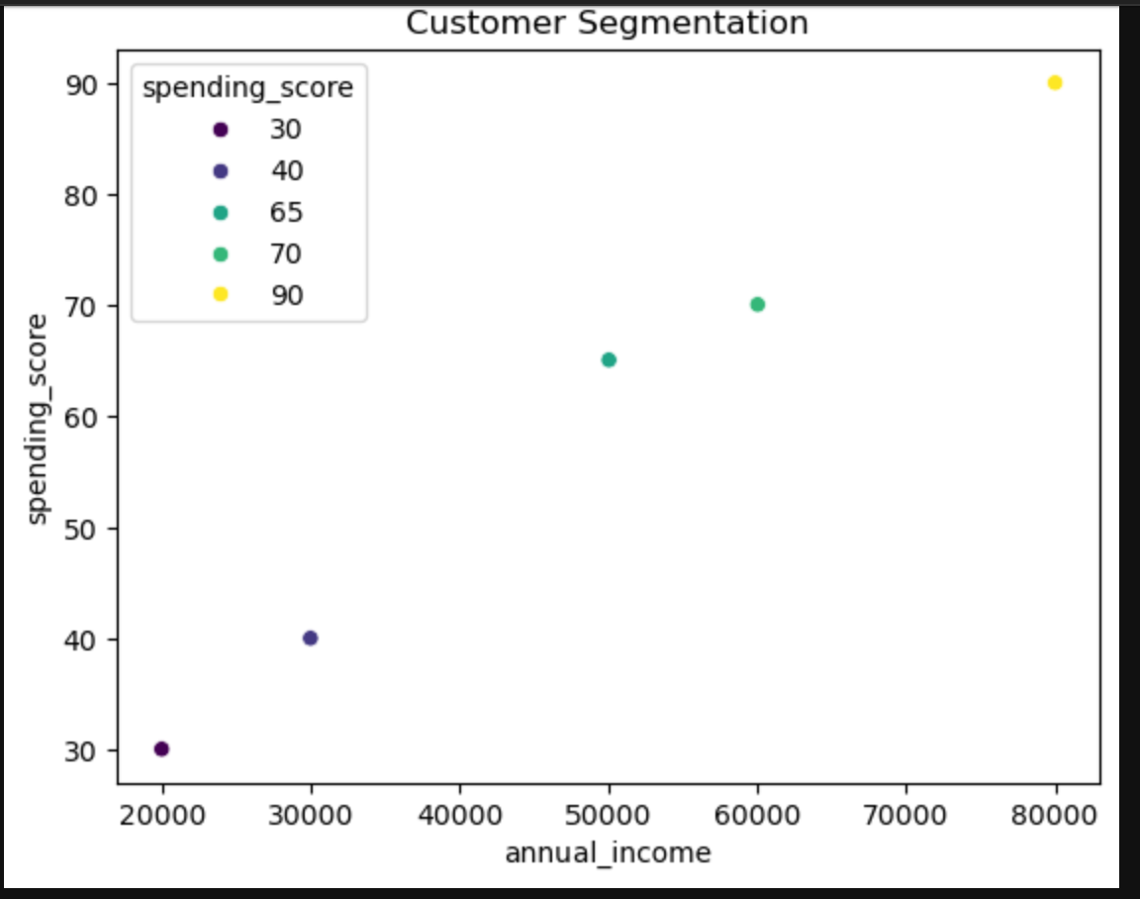

Program5 :
Model Result Visualization
You trained a classifier and obtained y_true and y_pred.
Write code using Seaborn to:
- Plot a confusion matrix heatmap
- Add annotations and color bar
- Clearly label predicted vs actual classes

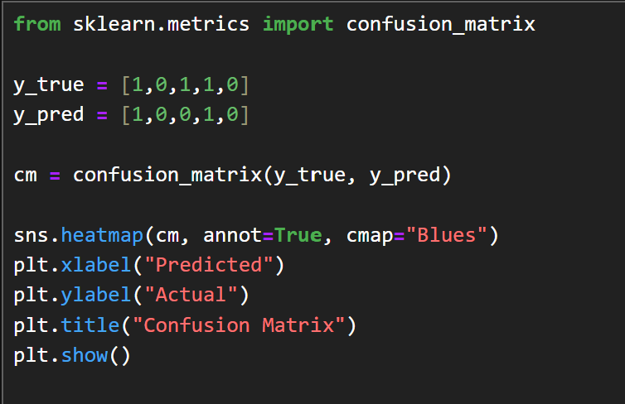

Output:
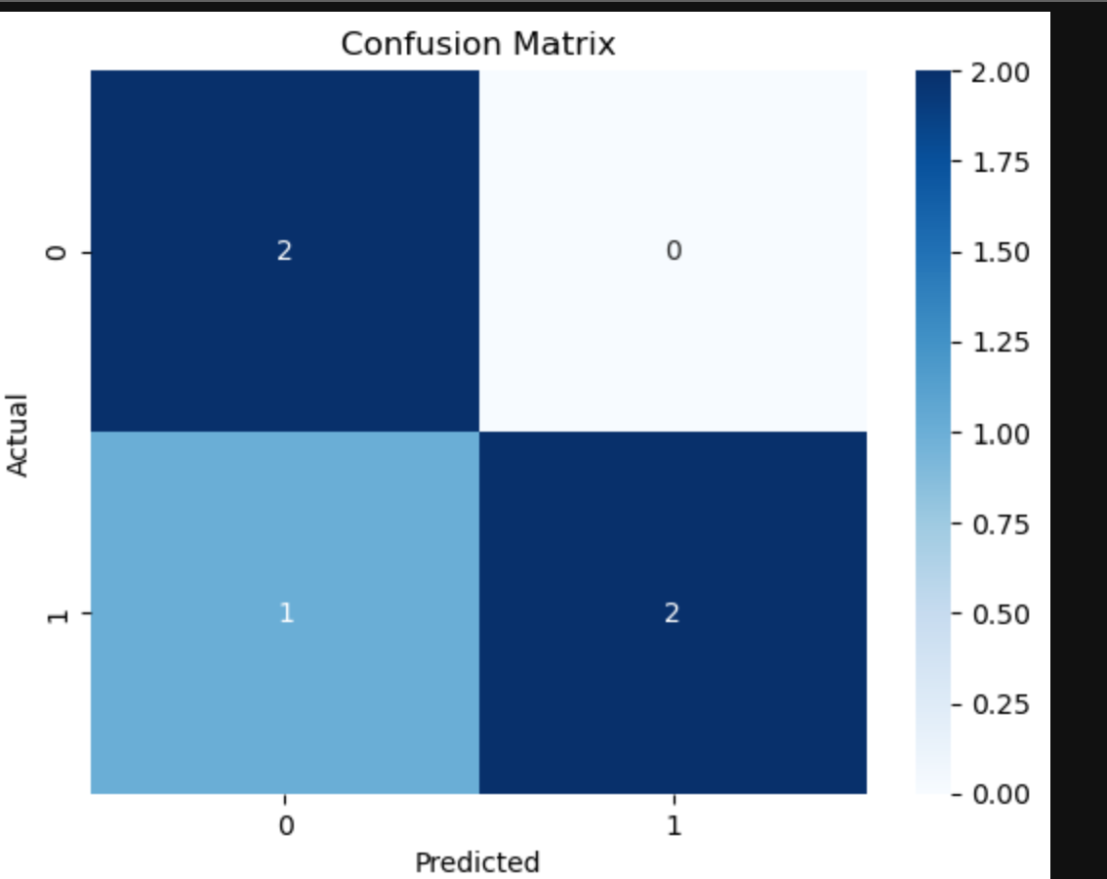
Q1. Telecom Customer Churn PredictionGiven customer data with features such as tenure, monthly_charges, and contract_type, and target churn.
Write a Scikit-learn program to:
- Encode categorical variables
- Train a Logistic Regression model
Evaluate using accuracy and confusion matrix

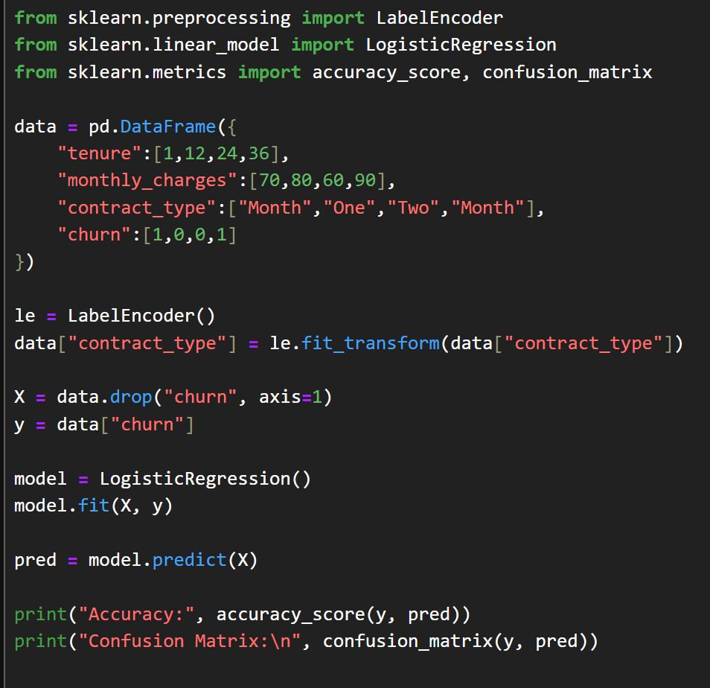

Output:
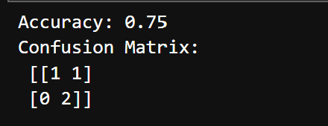

Q2. House Price Prediction
A dataset contains area, bedrooms, location_score, and price.
Implement a regression model to:
- Split data into train/test sets
- Train Linear Regression
- Predict prices and calculate Mean Squared Error

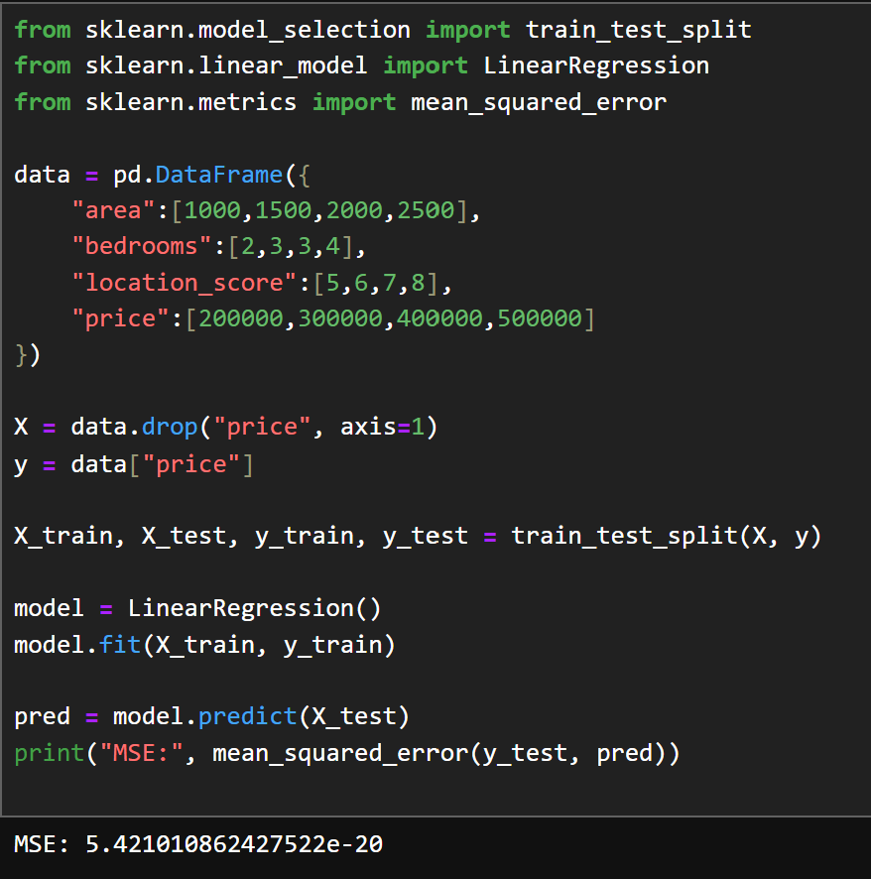

Q3. Disease Classification System
Patient data includes glucose, BMI, age, and outcome.
Write code to:
- Normalize the data
- Train a Decision Tree classifier
- Evaluate precision, recall, and F1-score

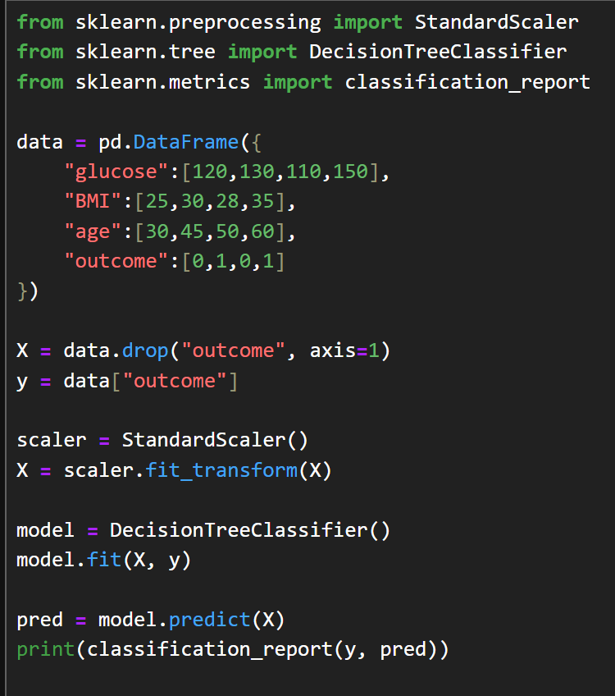

Output:
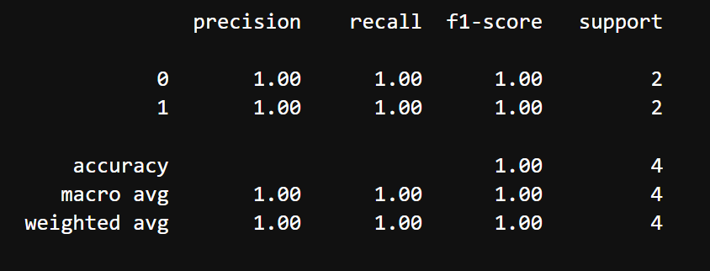

Q4. Email Spam Detection
You are given email text and spam labels.
Using Scikit-learn:
- Convert text to numerical features (TF-IDF)
- Train a Naive Bayes classifier
- Test the model on new email text
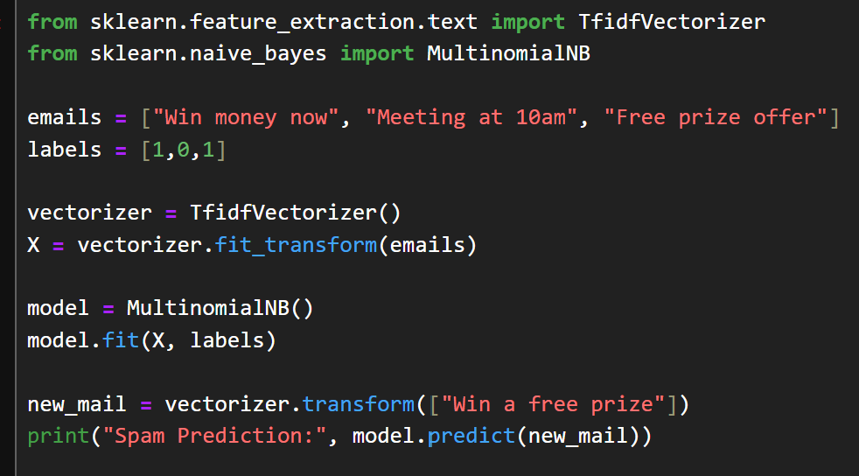
Output:
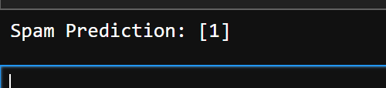

Q5. Student Risk Prediction
Student records include attendance, mid_marks, and final_marks.
Write a program to:
- Build a Random Forest classifier
- Predict whether a student is “At Risk”
Display feature importance

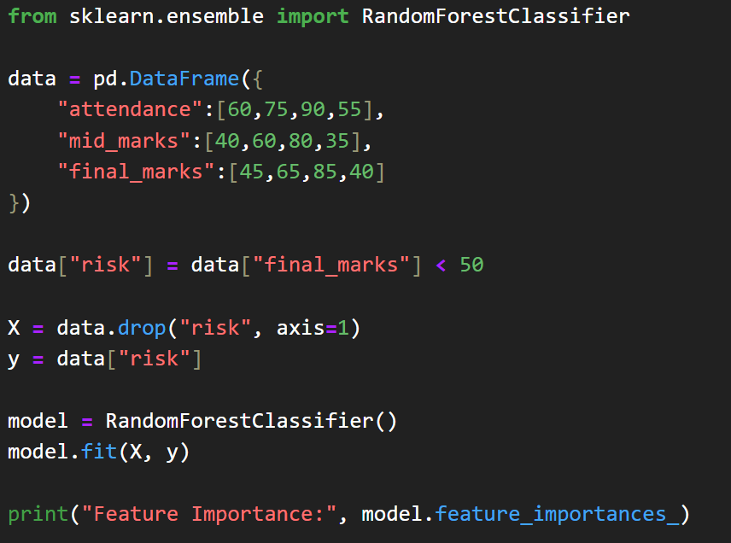
Outpuut:
